**KMS Python Script Explanation**

* **Import Required Libraries**



csv: This module provides functionality to read from and write to CSV files.

boto3: This is the AWS SDK for Python. It allows Python developers to write software that uses AWS services.

* **Define Helper Functions**

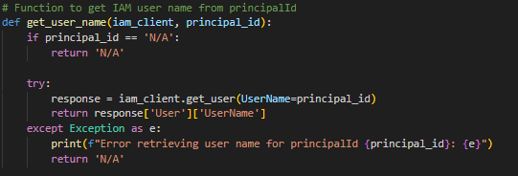

This function takes an IAM client and a principal ID as input, and it attempts to retrieve the IAM username corresponding to the principal ID using the iam_client.get_user() method.

* **extract_iam_username_from_events(events, iam_client)**

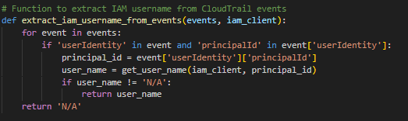

This function takes a list of CloudTrail events and an IAM client as input. It iterates through the events to find and extract the IAM username from the userIdentity field.

* **Create CSV File**

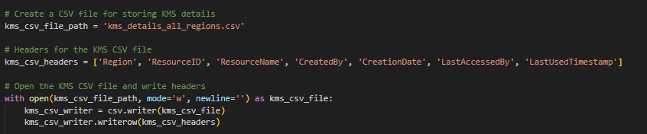

This section initializes a CSV file (kms_details_all_regions.csv) and writes headers to it.

* **Fetch AWS Regions**

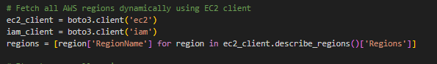

The script uses the EC2 client to dynamically fetch all AWS regions.

* **Iterate Over Regions and KMS Keys**

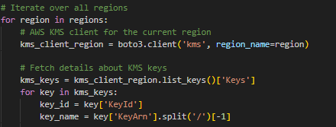

The script iterates through each AWS region and, within each region, iterates through each KMS key.

* **Fetch KMS Key Metadata**

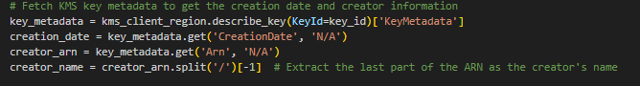

It retrieves metadata for the current KMS key, including the creation date, creator's ARN, and other details.

* **Check Key Manager (AWS or Customer)**



It checks whether the KMS key was created by an AWS service or a customer.

* **Extract Creator's Name**

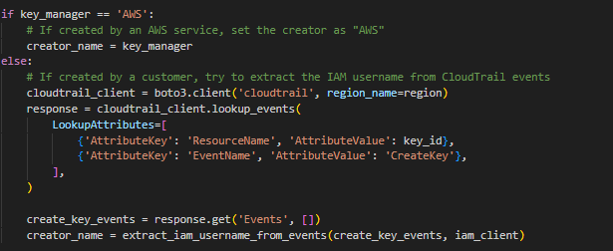

If the key was created by an AWS service, the creator's name is set to 'AWS'. Otherwise, it attempts to extract the IAM username from CloudTrail events.

* Fetch Last Accessed Time

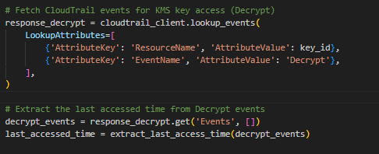

It fetches CloudTrail events for KMS key access (Decrypt) and extracts the last accessed time.

* **Fetch KMS Key Aliases**



It fetches the aliases associated with the current KMS key.

* **Write Data to CSV**



The script writes the fetched details (region, key ID, aliases, creator name, creation date, 'N/A' for last access details, and last accessed time) to the CSV file.

* **Print Completion Message**



It prints a message indicating that the KMS CSV file has been generated.

* **OUTPUT**



* **Missing Fields Explanation**

1. **KMS API Limitations:**

The AWS Key Management Service (KMS) API does not directly provide details about who created or last accessed a key. The API might not expose this information for security and privacy reasons.

1. **CloudTrail Events:**

The recommended approach is to use AWS CloudTrail events to gather information about key creation and access. However, due to the nature of certain AWS services or automated processes, CloudTrail events may not always contain IAM username information.

1. **Security and Privacy Considerations:**

The lack of direct access to creator or last access information from the KMS API and potential absence of IAM username details in CloudTrail events are intentional security and privacy measures designed to protect sensitive information.

Last access time details for cryptographic keys are sensitive information. AWS places a high emphasis on security and privacy, and exposing real-time or detailed access information could potentially pose security risks.

1. **Data Minimization Principle:**

AWS follows the principle of data minimization, meaning that only essential information is collected and exposed through APIs. Providing real-time access details for keys might not align with this principle, especially considering the sensitive nature of cryptographic keys.

1. **Use of CloudTrail for Auditing:**

AWS provides CloudTrail for auditing AWS API activity, but it may not capture every detailed aspect of key access, especially in near real-time. CloudTrail logs may be aggregated and processed periodically for efficiency, and detailed key access information might not be a primary focus.

1. **Service Design and Performance:**

AWS KMS is designed to be a high-performance and scalable service for key management. Real-time tracking of every key access could potentially impact the performance of the service, and thus, detailed access logs may not be provided.

* Git Repo:

KMS python script

<https://github.com/arjit547/KMS-SM/blob/main/KMS%20python%20script/kms.py>